Measures of Spread Name: Hana Kazmierczak
 | Yankees |  | Tigers
Position | Name | Age | Name | Age
C | Posada | 35 | I. Rodriguez | 34
1B | Wilson | 29 | Casey | 32
2B | Cano | 23 | Perez | 33
3B | A. Rodriguez | 31 | Inge | 29
SS | Jeter | 32 | Guillen | 30
LF | Cabrera | 32 | Monroe | 29
CF | Damon | 22 | Granderson | 25
RF | Abreu | 32 | Gomez | 28
DH | Giambi | 35 | Young | 32
P | Wang | 26 | Robertson | 28
When the New York Yankees played the Detroit Tigers on August 30, 2006, those teams had the two best records in the American League. Let’s compare the relative levels of experience for these teams by comparing the players’ ages.
- Create comparative dot plots using JMP (see the activity video) and paste the results below. Record the mean and median for each team. Comment on how the age distributions compare.
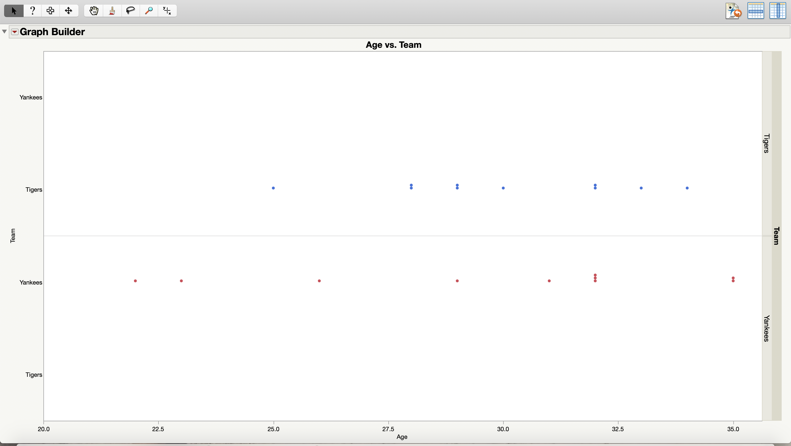
Yankee’s Mean_____30_
Yankee’s Median___32___

Tiger’s Mean__30____
Tiger’s Median__30____

- Because the centers of the age distributions are so close, can you reasonably conclude that there is no difference between the age distributions of these line ups? Explain.
Yes, since the centers of the age distributions are so close both teams have a relatively similar lineup when it comes to age.

- Which team lineup appears to have more variability in its ages?
Yankees

- Compute the range of the ages for each team.
Yankees: Oldest___35__ Youngest___22__ Difference (Range)____13_
Tigers: Oldest_34____ Youngest___25__ Difference (Range)__9___

- Another measure of spread is called the interquartile range (IQR). The lower quartile is the median of the lowest 50% of the data. The upper quartile is the median of the upper half of the data. The interquartile range is the difference between the lower and upper quartiles. Here are the ages for the Yankees in order. Find each value for this team.
22 23 26 29 31 │ 32 32 32 35 35
↑ median
Lower Quartile (Q1) _____26______ Upper Quartile (Q3) _____32_______ IQR_______6_______

- Find the IQR for the Tigers for the using JMP (ANALYZE → DISTRIBUTION → Q3 – Q1).
IQR for the tigers using JMP is 4

- The mean age of the Tigers is 30 years. Complete the missing entries for each player and total the columns.
Player | Age | Deviation from Mean | Absolute Deviation | Squared Deviation
I. Rodriguez | 34 | 34 – 30 = 4 | 4 | 16
Casey | 32 | 32-30=2 | 2 | 4
Perez | 33 | 3 | 3 | 9
Inge | 29 | -1 | 1 | 1
Guillen | 30 | 0 | 0 | 0
Monroe | 29 | -1 | 1 | 1
Granderson | 25 | 25-30=-5 | 5 | 25
Gomez | 28 | -2 | 2 | 4
Young | 32 | 2 | 2 | 4
Robertson | 28 | -2 | 2 | 4
Total | 300 | 0 | 22 | 68

- Find the average of the absolute deviation. This measurement, called the mean absolute deviation, is a sensible, but rarely used measure of spread.
MAD=22/10=2.2

- Calculate the value of the standard deviation of these data using the formula given below. This is a popular measurement of spread.
= $\sqrt{\frac{68}{9}}=2.75$

- Translate the values computed earlier. Use your calculator to find the value of the standard deviation for the Yankees (ANALYZE → DISTRIBUTION → Std Dev). Using the numbers, compare the spreads of the ages for the two teams.
Team | Range | IQR | Standard Deviation
Yankees | 9 | 4 | 3
Tigers | 13 | 8 | 5

We originally said that the Yankees were bigger than the Tigers. This table goes along with what we said earlier because the standard deviation is smaller for the Yankees which means there isn’t as many younger people on the team. Whereas the Tigers standard deviation is higher meaning they have more younger players on the team.
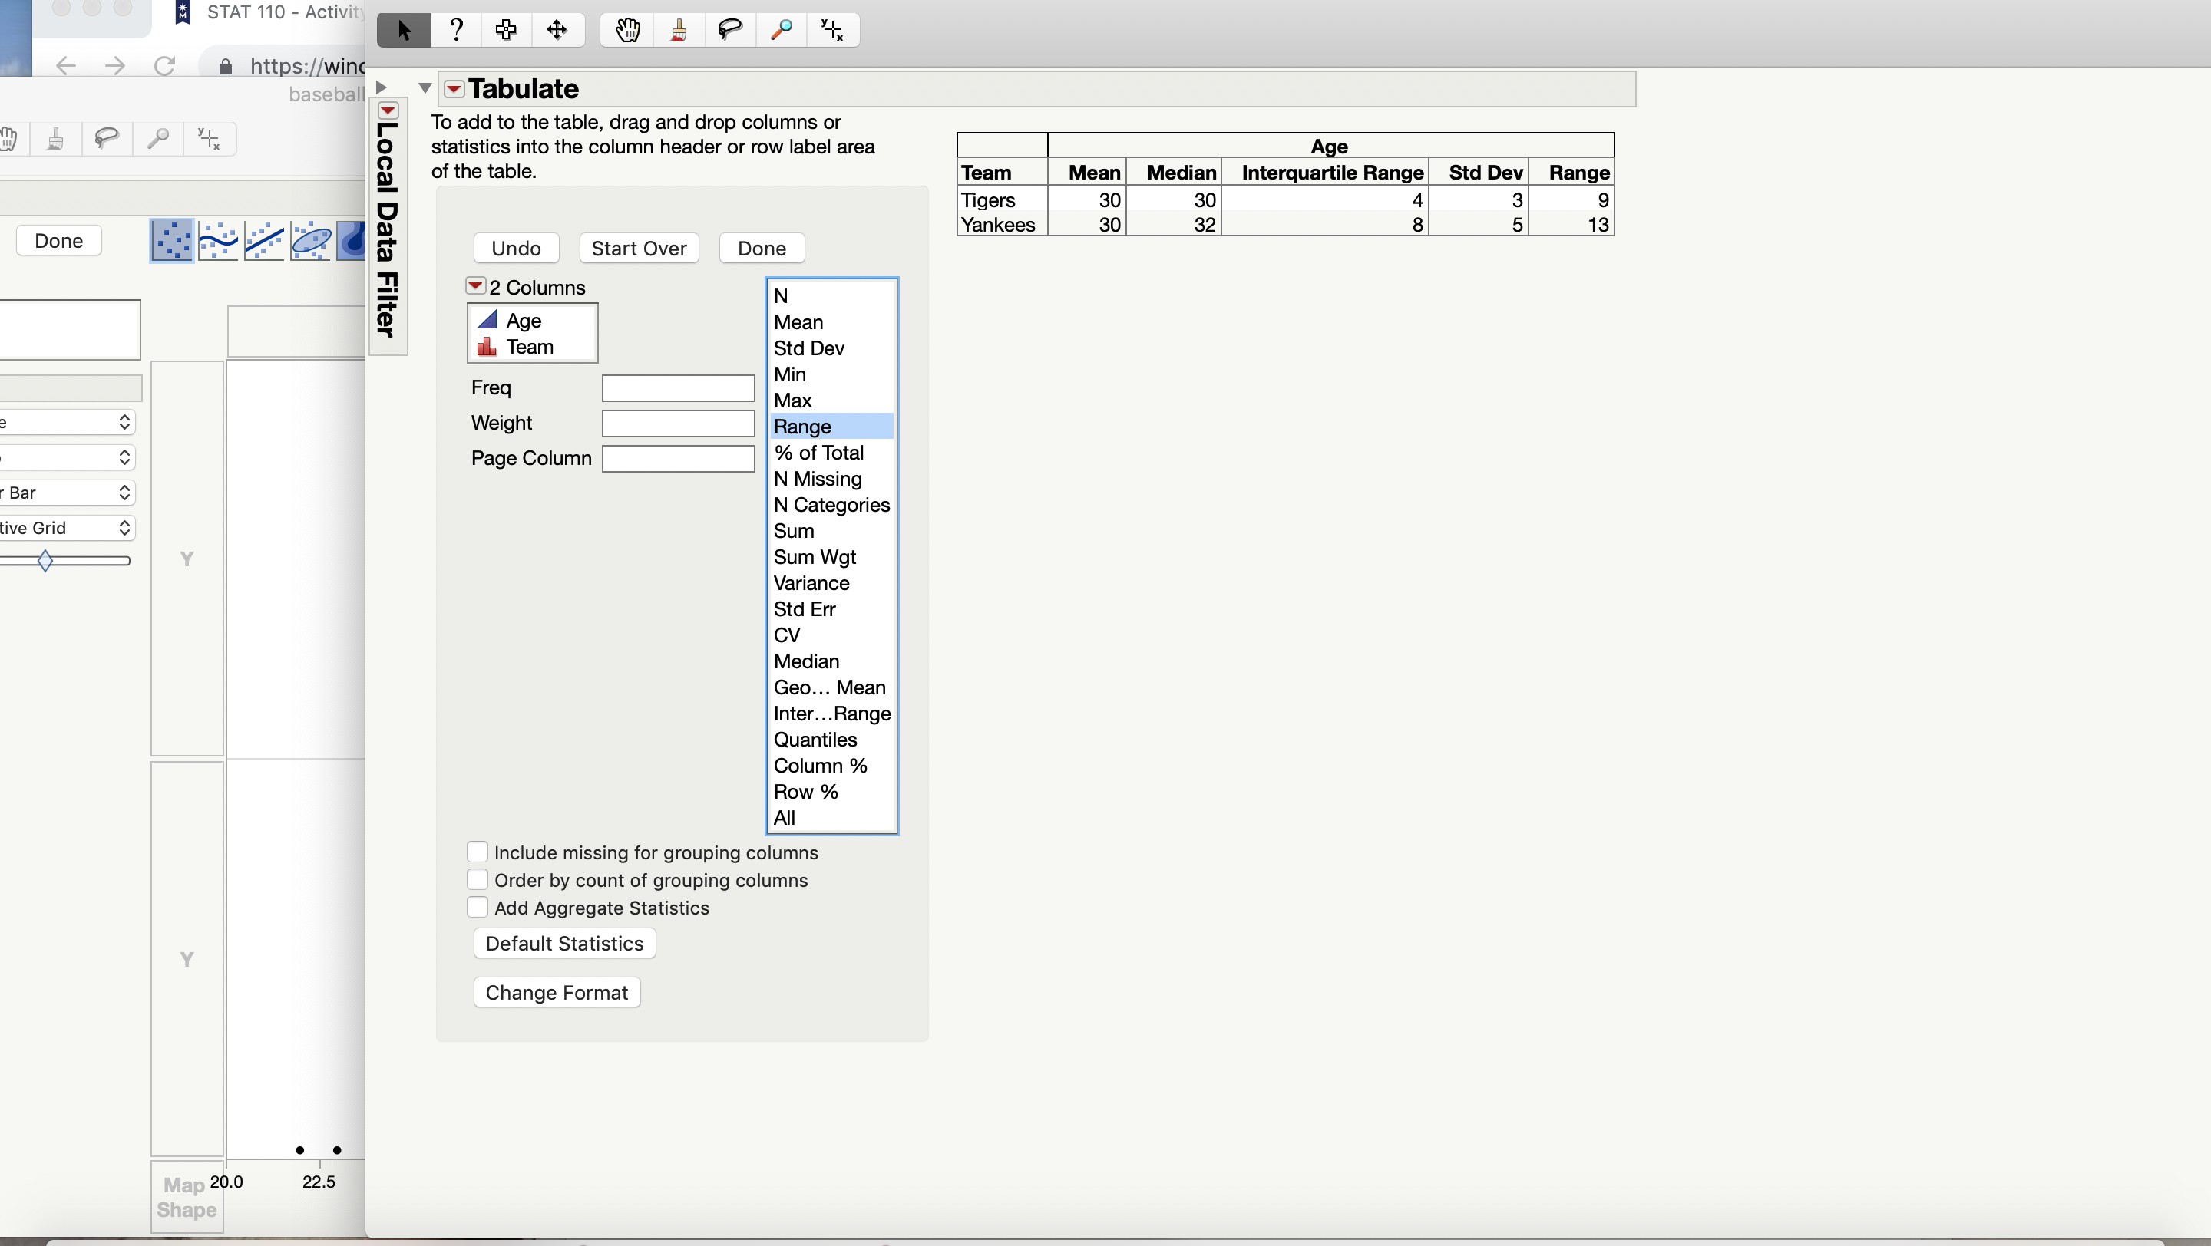

- Suppose that I. Rodriguez’s age had been incorrectly listed as 43 years rather than 34. Would you expect this change to have much/any effect on the value of the range? How about the IQR? How about the standard deviation? Explain.
Changing Rodriguez’s age doubled the range from the previous testing. It did not change the IQR, however, it did change the standard deviation by 2. Here is the data from changing Rodriguez’s age to 43.

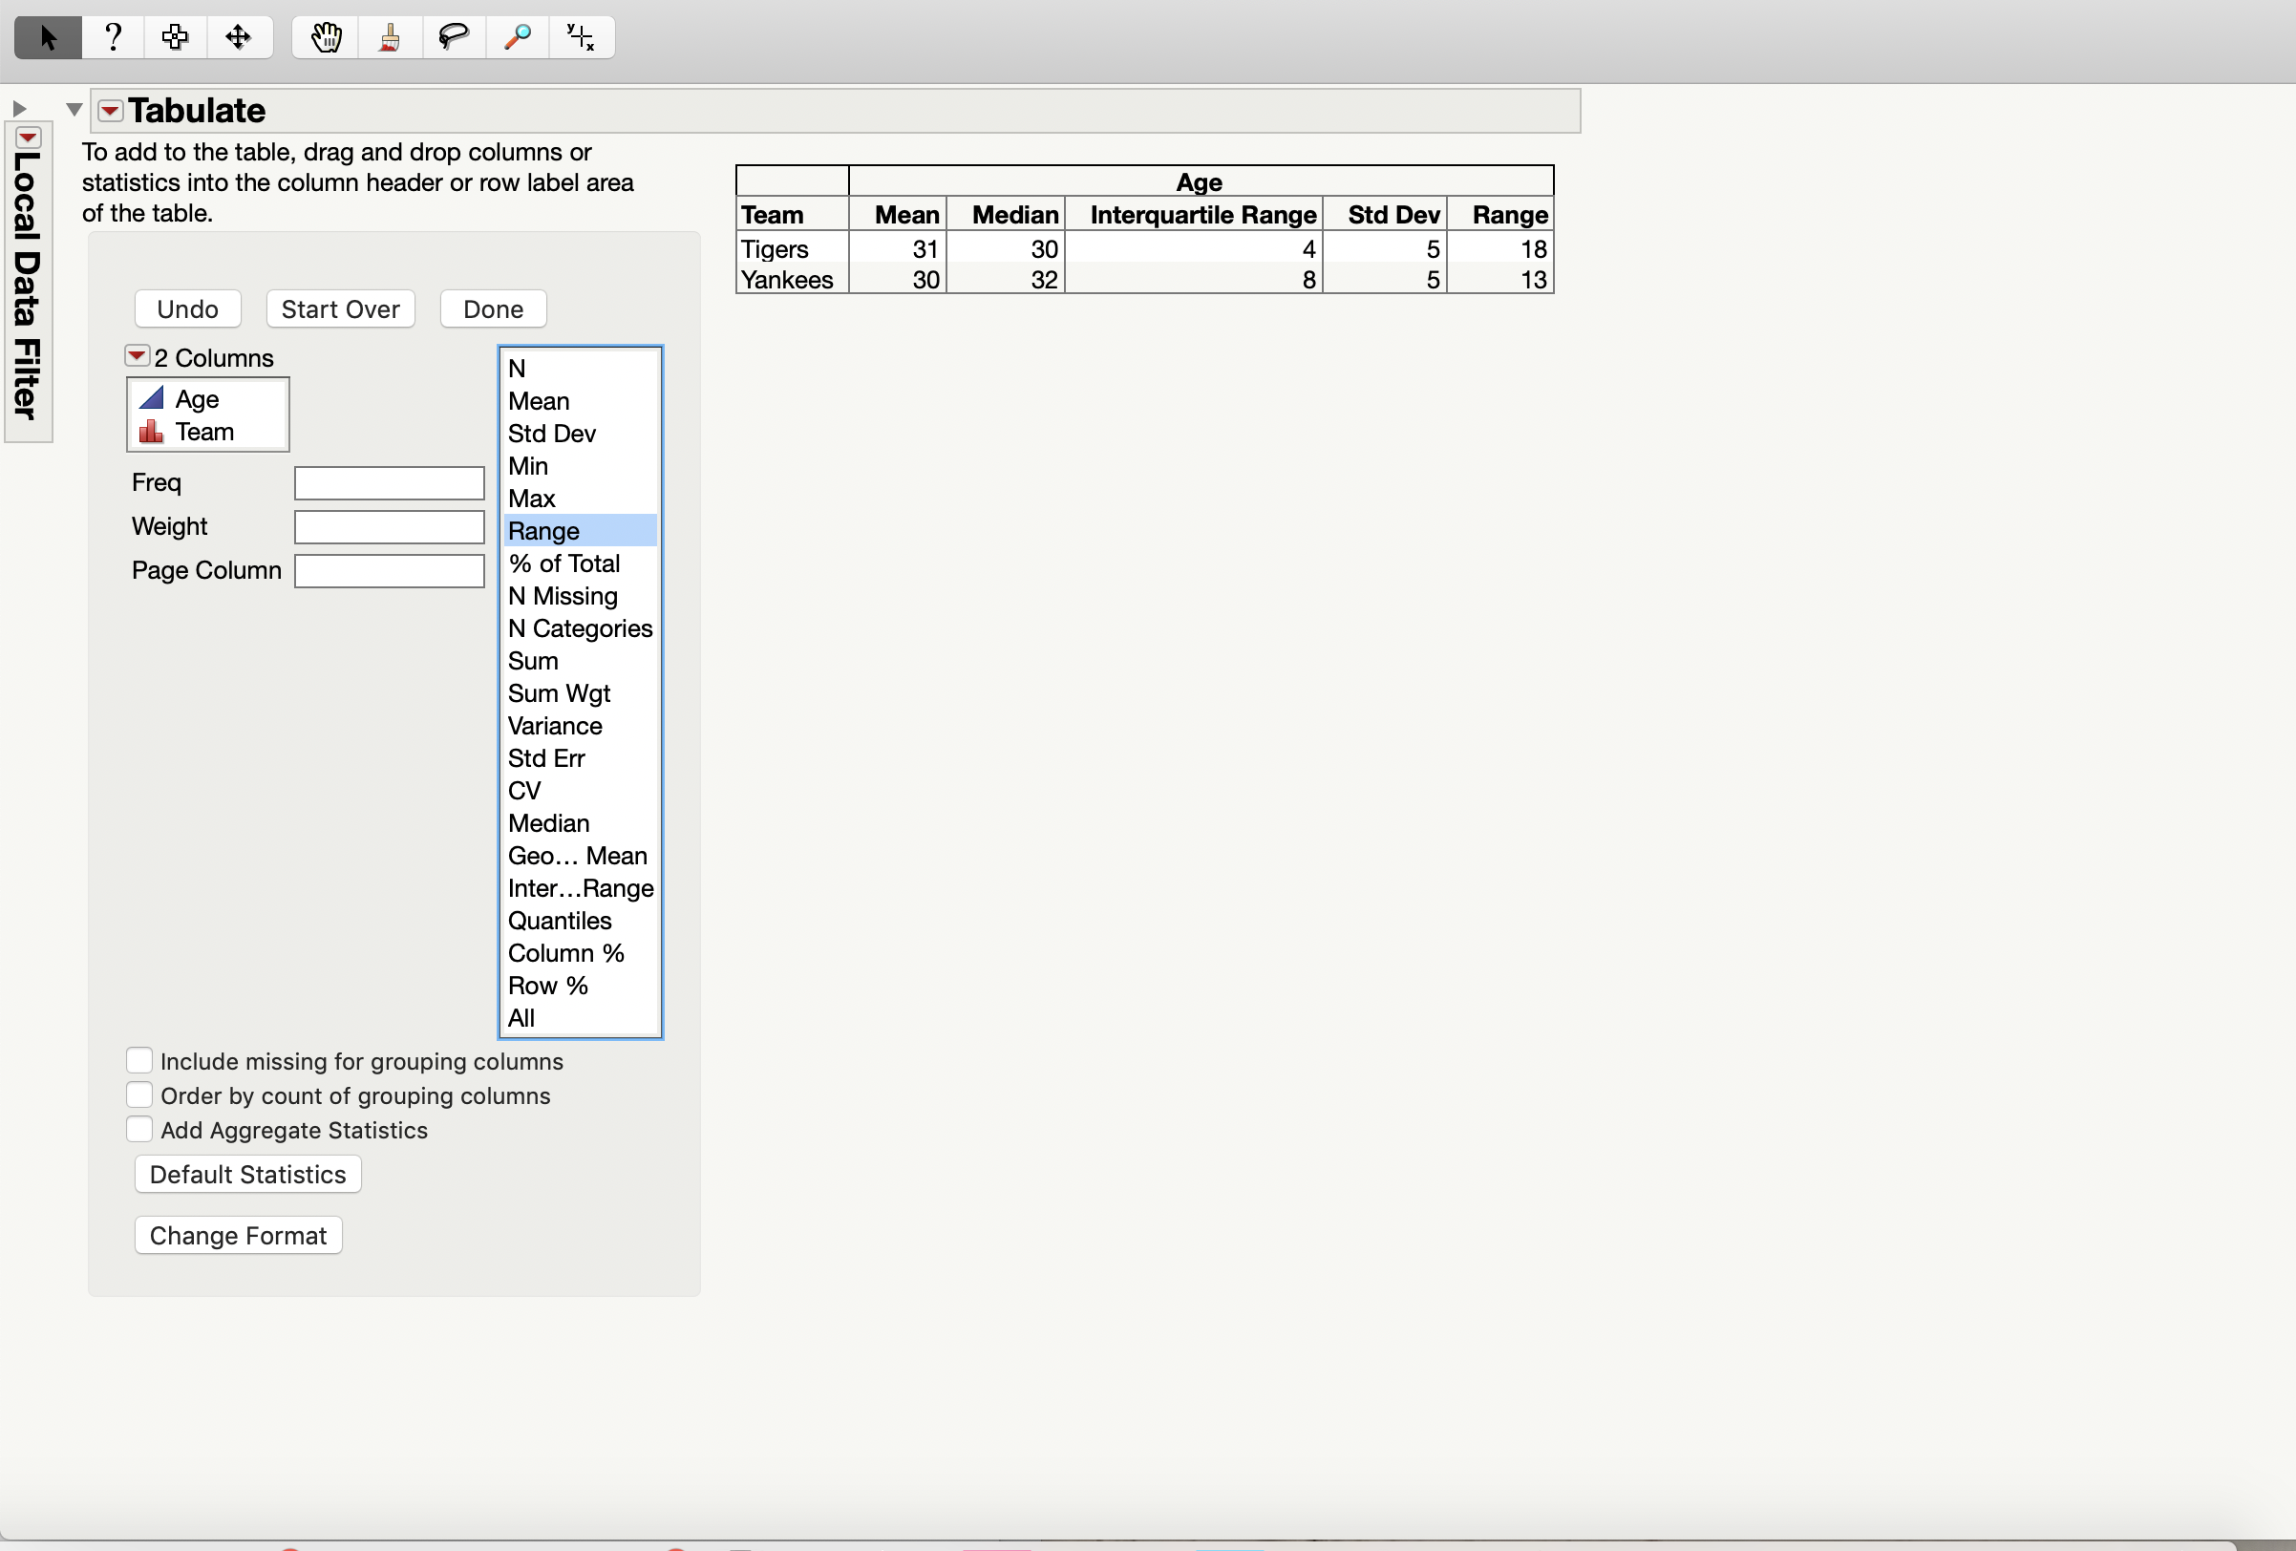

- Fill in the table below using your calculator to calculate the perspective values. For the second column, replace I. Rodriguez’s age with 43. For the third column, replace I. Rodriguez’s age with 134.
 | Original Data | With Large Outlier (43) | With Huge Outlier (134)
Range (Max – Min) | 9 | 18 | 109
Interquartile Range (Q3 – Q1) | 4 | 4 | 4
Standard Deviation (Sx) | 3 | 5 | 33

- Which of the measures of spread are resistant to outliers and which are not? Explain how you decided.
The measure of spread that are resistant to outliers is the Interquartile Range. I chose this because it is the only numbers on the data sheet that did not change because of the outlier. The other two, which are, range and standard deviation are not resistant to outliers.

